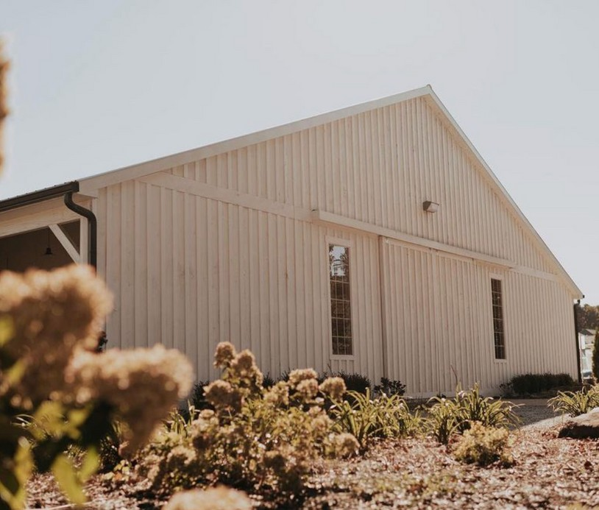
Venue Pricing

3 Oaks Farm & Events LLC

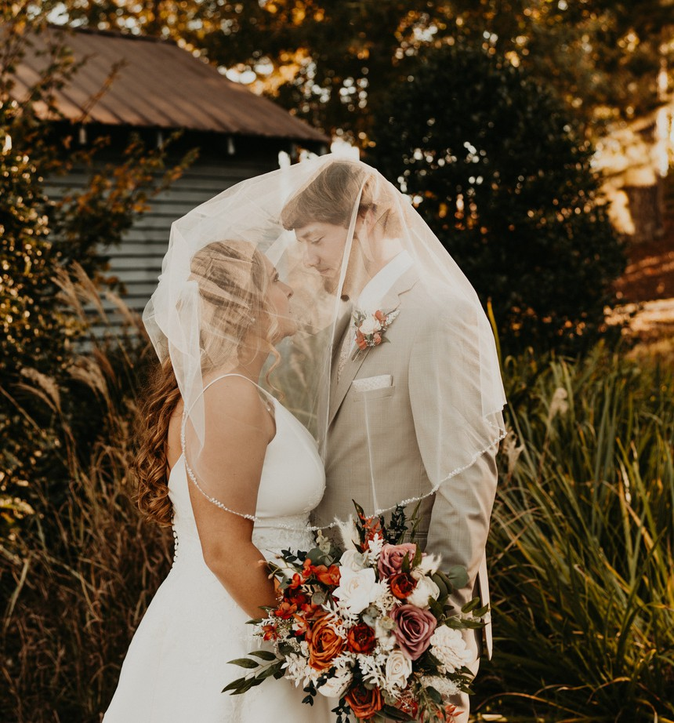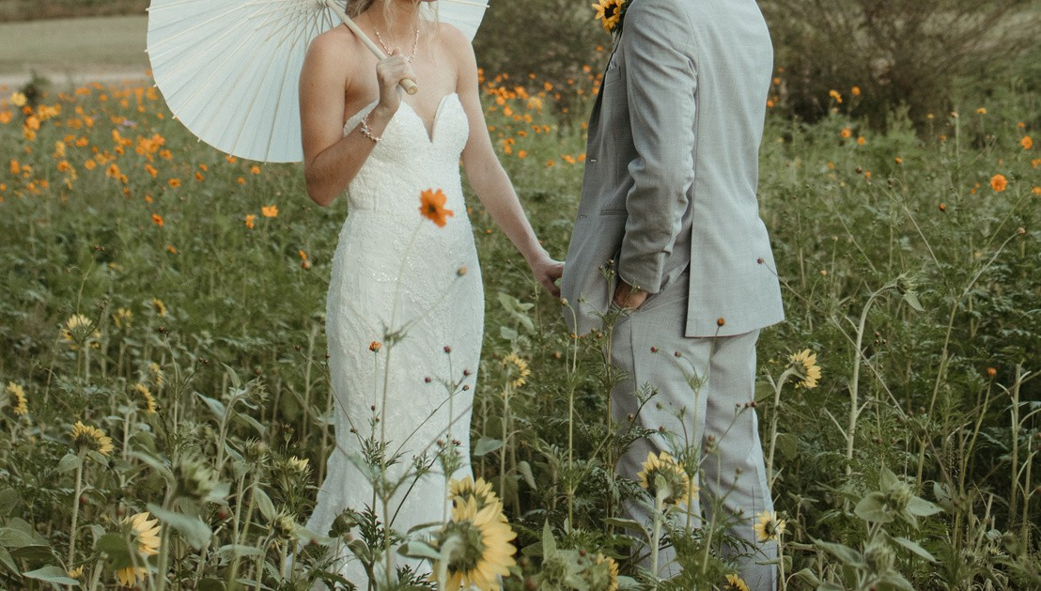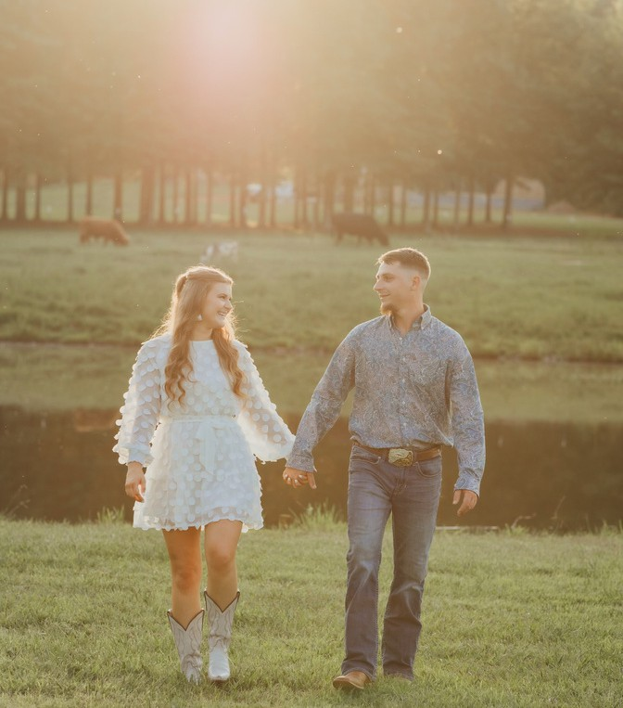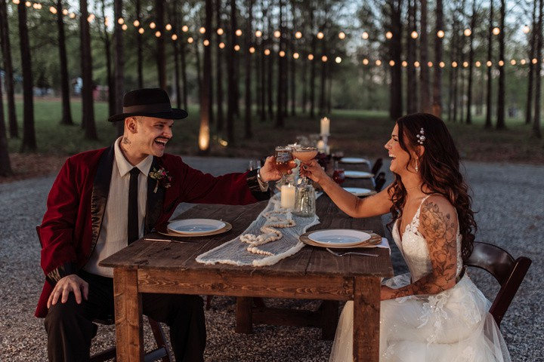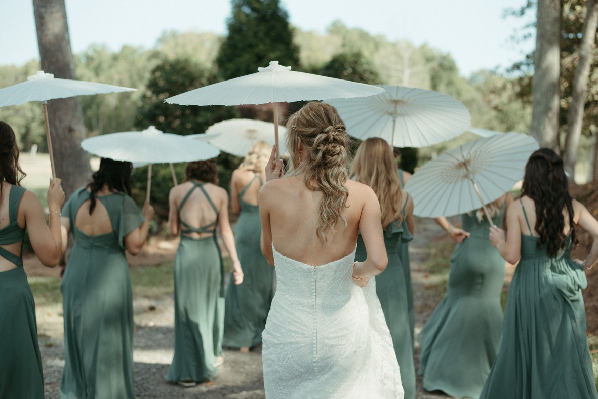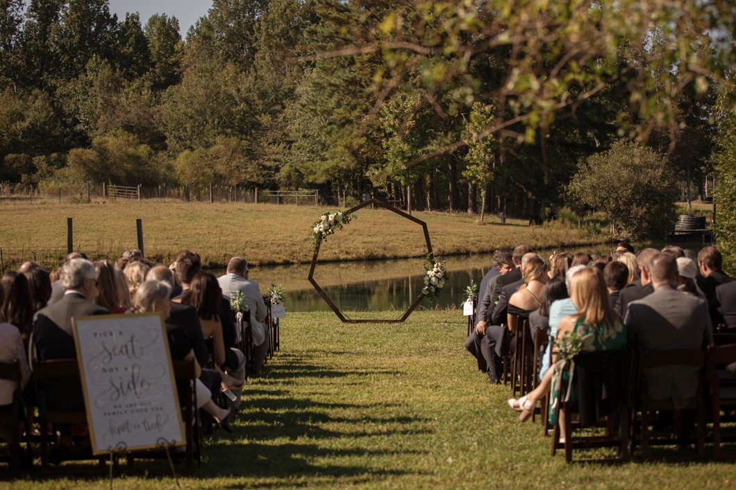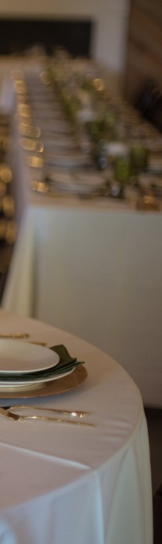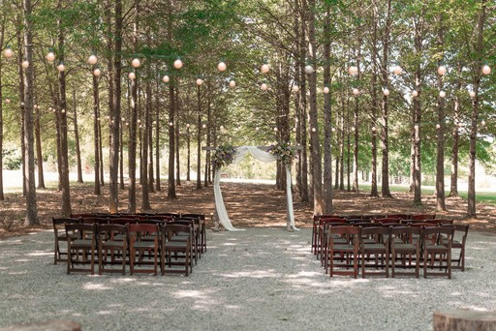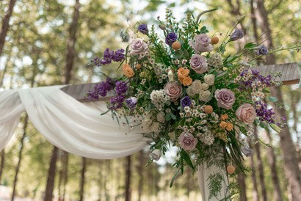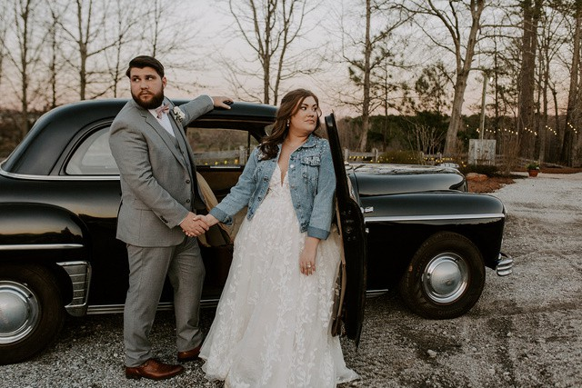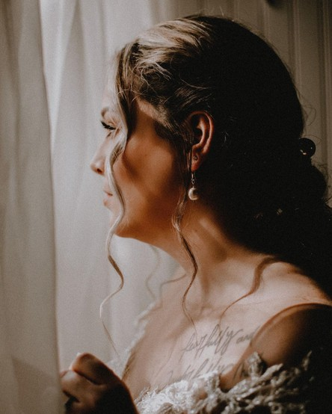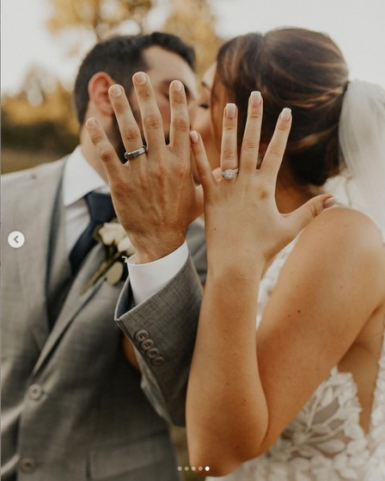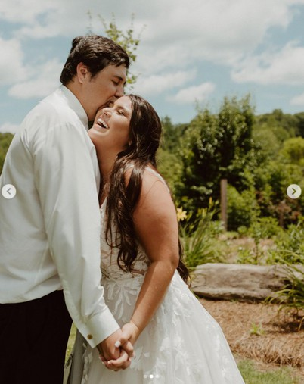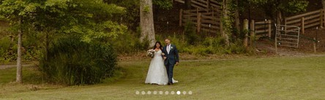
$4,950
Bundle option $6,200-2 Day use of property (11:00AM-11:00PM)
Requires a $500 Security Deposit - Refundable

Wedding Pricing Includes: Venue:
- Climate controlled venue
- Wooden benches in forest
- Tables (60 inch round guest tables / 4ft, 6ft, 12ft rectangular for serving/displays, etc.)
- Wood Chairs up to 150 guests
- 3 custom built high top tables
- 2 wooden barrels for inside use/2 for outside use
- Bridal cottage/groom’s room
- Golf cart assistance driven by 3 Oaks staff only
- Catering kitchen with private entrance

- Separate walk-up bar area
- Cleaning fee
- Venue staff

Logistics:
- Up to 12 hours on property ( 11am - 11pm)
- 1 hour rehearsal time
- 1 6month meeting/1 30 day meeting
Decor Closet Access Includes
- Gold, silver, or woven chargers
- Easels
- Vases
- Wooden discs
- Assortment of signage

Optional Add-ons
- Stand-up heaters: $75 each
- Vintage glassware place settings for 150 people ($6.00 includes plate/glass/flatware)
- 1949 Plymouth (photos only)
- Day of Coordination

- Reservation Fee: A non-refundable reservation fee of half of the venue fee is due at the time of signing a contract with 3 Oaks Farm to reserve your date/book your event. A refundable $500 damage/security fee is also required 30 days prior to your event.
- Liability Insurance: 3 Oaks requires all clients to secure a one-day event insurance policy naming 3 Oaks Farm and Events, LLC. As additionally insured.
- Vendors: We do have a Preferred Vendor list, but you may also utilize other outside vendors. Please note each vendor must submit their Certification of Insurance to 3 Oaks Farm no later than 30 days prior to the event.
- Alcohol: We do allow alcohol provided that clients hire a certified bartender (Forsyth County) and pay the cost of a currently employed FOCO police officer (arranged by 3 Oaks) to be present during your event. ($60 per hr/minimum 4 hrs) paid the day of the event.

At 3 Oaks Farm and Events, it’s our desire to provide a space for you to have the wedding of your dreams with the people that matter most in your life and create memories that last a lifetime-
We would love to partner with you to make that happen. Come and see if we have what you are looking for!
Call today to schedule a tour-

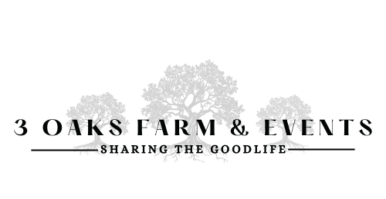 | Phone | Email
 | 706-974-4239 | lucy@3oaksfarm.org

