This unique, family-owned venue is set on a real working farm which provides an unconventional and rustic feel to any event. From the tree-line driveway, to the white- washed stunning barn, guests feel as if they have entered a charming and inviting retreat.
General Information

Features and Amenities

- Climate Controlled Barn 1
- Lake view Patio area with seating
- Manicured grassy area with lake view
- Waterfall
- Covered Bridge
- Food Prep Area
- 60” round tables (per guest count)
- Chairs (per guest count to 120)
- 12’ rectangular table for buﬀet service
- 6” table
- Custom built high-tops

General Event Fees:
Up to 75 guests $1750 up to 5 hours 76- 100 guests $2250up to 6 hours 101-125 guests $2750 up to 7 hours 126-150 guests $3250 up to 8 hours
  - Wooden Barrels
  - One-way drive for easy traﬃc control
  - Ample parking in grassed area
  - Convenient drop-oﬀ for guests
  - Handicap parking with van access
  - Gender neutral restrooms (2)
  - Handicap Accessible restroom
  - Private caterer’s entrance
  - Custom made barn door through out
  - Painted concrete ﬂoor in main hall

Rental Pricing
(Our Fees are subject to change)

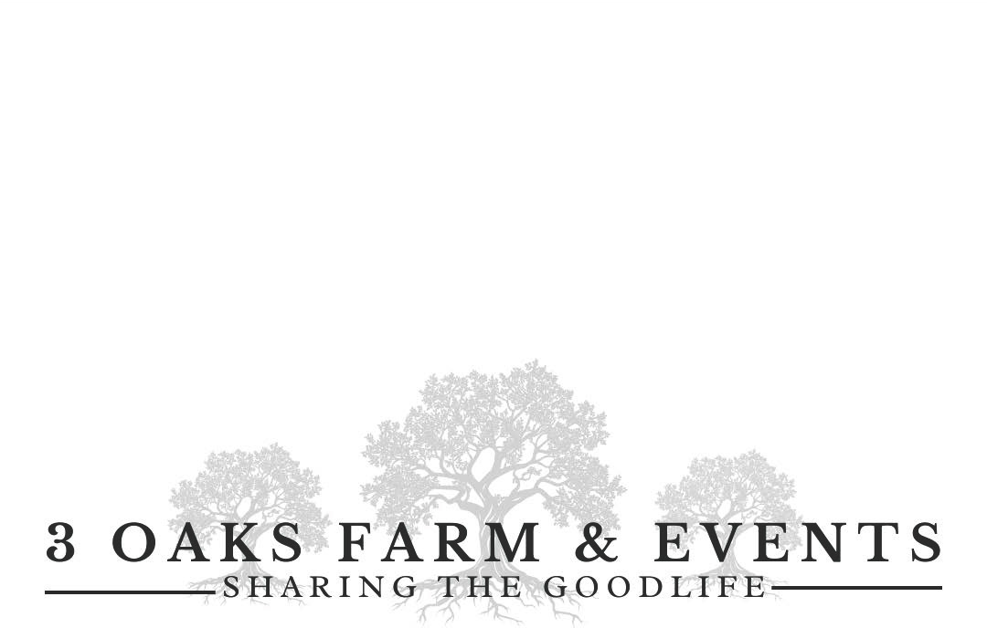
$500 Damage fee, may be refunded within 30 days if all conditions are met including adhereing to guest count and event timeframe.
Optional Fees:

- Rentals arranged on your behalf by 3 Oaks Farm.
- Golf cart transportation and staﬀ member to drive ($125)
- Oﬀ-Duty oﬃcer if alcohol served ($60/hour/4-hour minimum)
- Cottage uses for event $150 an hour



Reservation Fee/Deposit
We require a 50% retainer on the date you sign your contract to secure your date. . All retainers are non-refundable.
Liability Insurance
We require our clients to secure a minimum $1,000,000.00 Special Event liability insurance policy for the day. Your insurance agent can guide you through this process. Alcohol service shall require the addition of a liquor liability policy and require a licensed bartender. 3 Oaks Farm and Events, LLC shall be named as an additional insured on all insurance policies. This is to cover you, all your vendors and 3 Oaks Farm in the event of an accident.

Items not Included in General Pricing

- Caterer or servers/staﬀ to clear tables
- Photographers or videographers
- Decorators
- Oﬀ-Duty Deputy ($60 per hr/4 hr min)
- Liability Insurance
- Flowers/Floral Design
- Use of ceremony sites
- Parking Attendant
- Porta-Potty if guest count is over 150
- Tents if weather is a concern or guest count over 150
- D.J. or Band
- Bartender
- Table Linens
- Table Settings
- Tents or other rented items
- Use of Cottage (may be used for an additional fee)
- Golf Cart
- Gold or silver chargers
- Patio heaters

General Rental Usage and Guidelines
- Deposits/Reservation fees are non-refundable
- The gates will be open promptly at the beginning of your rental time and you will be reminded one hour prior to your ending time.

Set-up, event time and break down are all within your designated rental time. Extra time may be purchased if needed.
- All guests, vendors, clients must park in the grassy area. The gravel area is for vendor loading/unloading, drop-oﬀ/pick-up, food trucks and vehicles as identiﬁed with handicap identiﬁcation
- All your vendors coming onto our property must have proper licensing and provide us with a Certiﬁcate of Insurance
- We do not allow vehicles including vendors with campers, food truck or cars to drive or park on the stone patio in front of the barn.
- All our facilities are smoke and vape free. The designated area is at the ﬁre pit. Smoking is not allowed at any other location on our farm.
- Decorations shall not be attached to the wall ﬁxtures. Push pins and painters’ tapes only may be used to secure items to walls. These must be completely removed during clean/up time.
- No rice, glitter, small beads, confetti, or silk ﬂower petals will be used inside the building or in the ceremony sites. Materials we must pick up on the grounds will result in loss of damage deposit.

2

Open ﬂames are prohibited throughout our venue only battery-operated candles.
- We3 have a space for food prep only. The prep area must be left clean with counters wiped down, food removed, refrigerator must be emptied of your food and beverages
- All food must be cooked prior to bringing to the venue except for fully contained food trucks.
- Children must be ALWAYS supervised by an adult. Do not allow them to roam the property freely.
- Gate at the pathway should remain closed. Children are not permitted beyond this point without adult supervision
- Pets are not permitted in our buildings except for service dogs.
- This is a live, working farm, all guests must stay in designated areas. We also have insects so advise your guest accordingly.
- Our property goes to the water. Do not cross the bridge. Please do not trespass on our neighbor’s property.
- Our lake is not for swimming. It is not sanitary.
- Trash cans are provided with bags. All trash must be bagged and placed in the dumpster
- According to the Forsyth County Noise Ordinance, all music is oﬀ at 10 P.M. no exceptions.

All guests and vendors must be oﬀ the property by the end of your designated rental time, and it will not exceed 11PM. no exceptions.
- Vendors must coordinate their arrival and set-up time in advance with our site manager. Vendor set-up time must be within the designated rental time. Contact information for each vendor must be available 2 weeks prior to your event.
- The client is responsible to make sure that personal items have been collected, trash disposed of, and decorations removed by the end of your rental time.
- Tables must be cleared of all décor and linens.
- Alcohol can only be served by a Forsyth County Licensed bartender, no exceptions.
- No one under the age of 21 shall be served or consume alcohol.
- When serving alcohol, we require an oﬀ-duty Deputy. However, you may request a deputy for any event. We will arrange the deputy with the Sheriﬀ’s Oﬃce. The fee is your responsibility and is $60 and hour with a 4-hour minimum. The oﬃcer will be on duty the entire time alcohol is being served and up to guest departure time.
- We adhere to the Forsyth County Noise Ordinance Sec. 34-153. Music and noise shall not exceed sixty-ﬁve (65) dB(A). Any ﬁnes imposed will be the responsibility of the client. Periodic sound checks will be made with a digital sound level meter. Representatives of 3 Oaks Farm and Events, reserves the right to ask the music/noise level to be lowered.
- Fireworks are prohibited on our property.
- Fees are subject to change
- For the comfort of your guests, if your guest count exceeds 150 you must rent a port-a-potty and a tent if weather is a concern
- 3 Oaks Farm and Events, LLC, and its representatives, reserves the right to request any person or group of people acting unruly, engaging in an aggressive or destructive manner, or behaving in a disrespectful manner to staﬀ to leave the premises.

